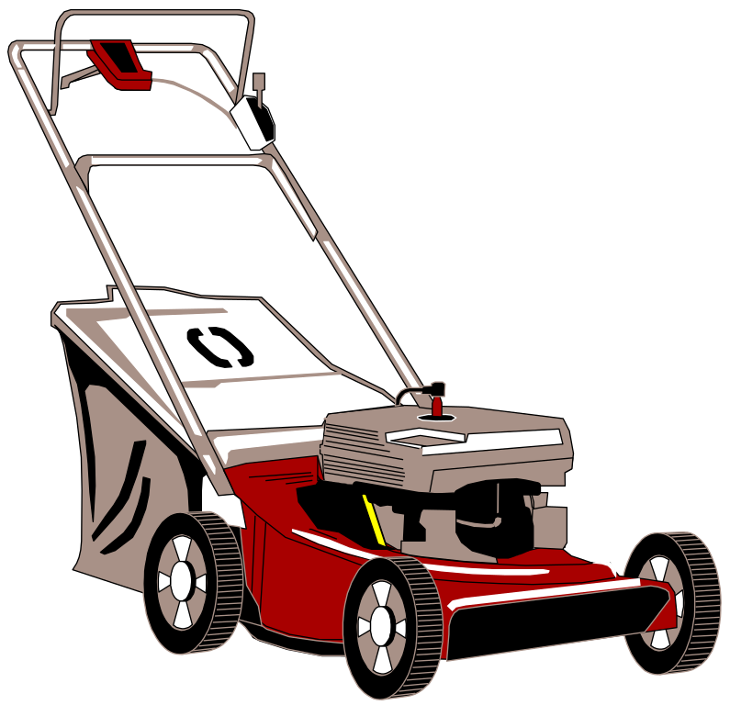The analysis stage involves identifying the end-user and functional requirements.

End-User Requirements: These are what the users of the website expect to

be able to do.

Functional Requirements: These are the processes and functions the system must

perform along with the information the system will have to

store to carry out these processes and functions.

**Read the discussion between a web developer (D) and their potential client (C). Use the information contained in the discussion to identify the end-user and functional requirements.**

**Write your answers on the following page.**

D: “You said on the phone that you are looking for someone to create a website about grass?”

C: “In a way, but what I’d like to focus on is lawns. Lawns are an area of gardening that people can become obsessive about. I should know, I’m a member of a lawn club and spend hundreds of hours a year maintaining my perfect lawn. The club members use each other's expert knowledge to find out about planting lawns, different types of grasses, lawnmowers, and fertilisers. I would like to collate all this knowledge into a website that can be accessed by everyone.”

D: “Would you like the website to be specifically for your lawn club?”

C: “No, the website should be for everyone interested in growing and maintaining a

great lawn.”

D: “Tell me more about planting or how you create a lawn.”

C: “Lawns are planted in autumn, spring, or early summer when the soil is warm but

the air is cooler. There are two ways to create a lawn; planting seeds (there are

lots of varieties) or laying turf. Both methods have their own rules for preparation and care. I can arrange for our club members to supply videos of each method. Once the grass is established there are a variety of organic and inorganic fertilisers that can be used to help maintain healthy growth. As well as offering advice on each I’d like the website to have pages where recommended inorganic and organic fertilisers are listed”

D: “Are there different categories of lawn mower used to cut grass?”

C: “The two main categories are push and sit-on but there are also several robot grass

cutters now available. The website should contain advice and photographs of

each type, along with simple rules on how and when to cut lawn grass.”

D: “You mentioned different types of grass.”

C: “Yes. The type of grass you pick for your lawn is very important.

Varieties of grasses are roughly categorised as cool season or

warm season. The exact variety of grass you select from each

category for your lawn depends heavily on the conditions in your

own garden”

D: “Describe the users of the website.”

C: “I am expecting most of the people reading the website to be

keen gardeners already who are looking for in-depth information

about the topics we’ve discussed.”

|  |  |
| --- | --- |
| **End-user Requirements**  **(5 marks)** | **Functional Requirements**  **(5 marks)** |
| Info on planting Lawns | Page about Planting lawns |
| View the recommended organic and inorganic fertilisers | Pages for both types of fertilisers |
| View info on Lawn Mower Types w/ photos | Page on Lawn Mower Types  Images of Both types |
| See Info on Different Types of Grass | Page on different types |
| Watch videos on how to maintain lawns | Page with functional videos  Videos on lawns |
|  |  |
|  |  |
|  |  |
|  |  |